This needs to be returned by ______________________

Dear Parents,
In science class we have discussed “Atomic Attire”, a project to be completed in class. Each student will have the opportunity to research an element from the Periodic Table. Students have a choice of two projects:
- Element T-shirt – If you choose this project, please bring plain white t-shirt to class. Here is an example of what the front of the t-shirt must have on it.

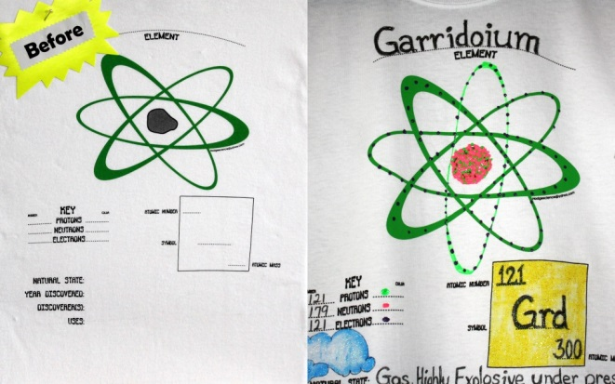

- Create a mobile or model of one atom from your element. This will be constructed during class time so you will need to bring your supplies and materials for the model construction. Below are some examples.
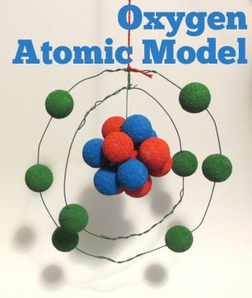 or 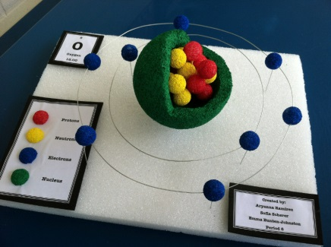
____ I will make a dimensional model of my element and will bring my materials to class for construction.
Student’s name/per. ___________ Parent signature: ___________________

